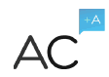

Absolute Results: Mobile Training App Proposal

Introduction 3

Creative Overview 3

Game “Demo” 4

Core Game Description 4

Progression Systems 9

Badges 9

Levels 10

Reward System 10

Retention Mechanisms 11

Unlock New Game Content 11

Increase Quiz Game Difficulty 12

Platform 12

Releases 13

Phase 1 13

Phase 2 13

Phase 3 14

Collaboration Tools 15

Technology 15

Organization 16

Development Process 17

Development Phases & Initial Timeline 17

Budget and Milestones 18

AC+A is… 19

Design 19

Engineering 19

Art 20

Audio 20

Quality Assurance 20

Project Management 20

Introduction

AC+A has experience in designing and developing games for a variety of clients. We leverage that experience as well as our extensive cross-disciplinary skills to deliver engaging social mobile products to satisfied customers all over the world. For more on AC+A, see our corporate overview PPT: [www.adriancrook.com/intro](http://www.adriancrook.com/intro)

We’re excited to do the same for Absolute Results.

Creative Overview

The Absolute Results mobile training app is a convenient way for car salesmen to practice their sales techniques, whether it’s in preparation for a Private Sale or just to brush up on their skills. This app transforms Absolute Results’ training materials into a stylish and easy to use mobile app that features a fast, replayable quiz game.

Salespeople can use this app any time they'd like to refresh their knowledge of the best ways to overcome common buyer objections, present incentives, and increase their repertoire of sales tactics. This helps them successfully close more sales, bringing even more value to the services offered by Absolute Results.

Everything discussed in the following sections will be included in a “Phase 1” version of the app (the initial release). Please see the “Phased Rollouts” section to view concepts for additional features for later phases and releases.

In our proposal, the term “game” is used to refer to the interactive training content and supporting systems, while the term “app” is used to refer to the entire application as a whole.

Game “Demo”

We have created a brief “demo” of gameplay. In this demo, the user progresses through a series of screens that simulates the appearance and functionality of the final version of app. All of these screens and functionality are described in the document below, so don’t worry if you don’t understand all of the features.

Also, **please note** that this demo is intended to be a representation of how the final app will look and function, and currently does not include animations nor support most game features. Consider it as more of an “on-rails tour” of the app.

The demo link will work on desktop as well as iPhone 5 (Safari mobile).

Please control-click here to view the main demo: [**http://invis.io/SK1F29PBJ**](http://invis.io/SK1F29PBJ)

Here’s an additional demo showing Chrysler/Jeep specific content: [**http://invis.io/6C1G3WWKV**](http://invis.io/6C1G3WWKV)

Core Game Description

The training app features a core game loop, called a game session, which is easy to complete and is infinitely replayable.

New users begin by creating an account and filling out basic information, such as their name and the dealership where they work. After logging in, they will see a landing screen showing a summary of their overall progress, as well as a large button that says “PLAY NOW!” Clicking “PLAY NOW!” starts a new game session.

During a game session, the user is trying to sell a car to a potential buyer. They need to correctly describe buyer incentives and overcome a series of buyer objectives by offering the ideal responses. The incentives, objections and responses are all based on the pre-existing content from the Objection flashcard deck. The user’s goal is to answer 15 questions correctly to complete the session and “close the deal.” *[Final number TBD after playtesting.]*

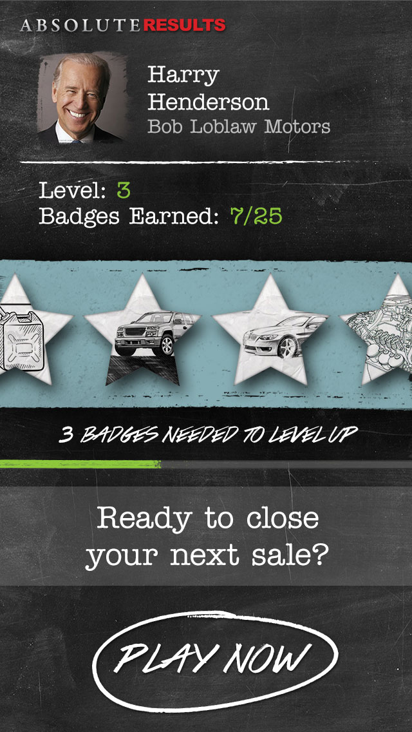 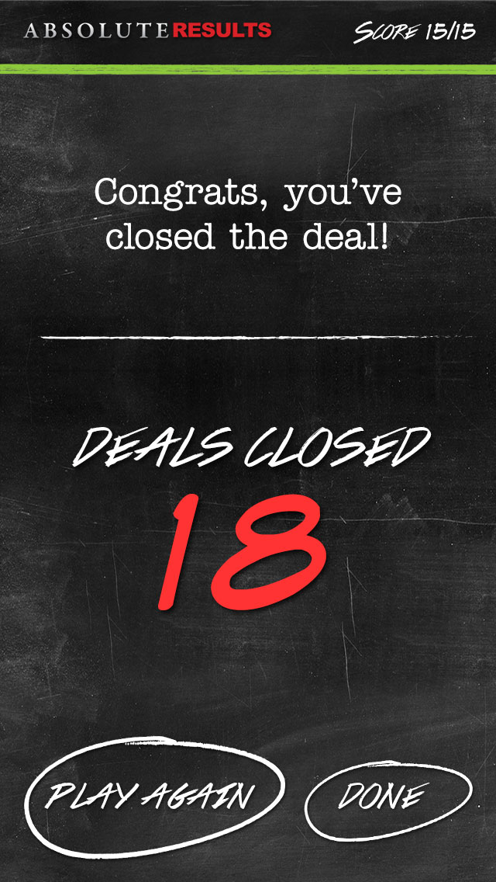

*Landing screen (left) and screen shown when player completes a quiz session (right)*

There are two types of question to provide variety and different levels of challenge for both new and advanced users.

* **Standard Questions:** User reads a buyer objection, and has to choose the correct response to that objection from a multiple choice list of answers. Or, user reads a buyer incentive, and has to select the correct supporting statement.
* **Reverse Questions:** User reads the ideal response to an objection, and then has to choose which objection it’s paired with from a multiple choice list of answers. Or, user reads a supporting statement, and has to choose the buyer incentive it’s paired with.

If the user selects the correct answer to a question, they are visually rewarded with pop-up text that says “Correct!” with a green checkmark, animation and so forth. Then they advance to the next question in the session. If the user selects the incorrect answer, they will see “Incorrect!” pop-up text and then advance directly to the next question. (Users are not allowed to answer the same question multiple times until they get the correct answer.)

A progress bar tracks the user’s advancement through each session. Once the user has given 15 correct answers, the session ends and the user is rewarded for their efforts (see “Progression Systems” section below).

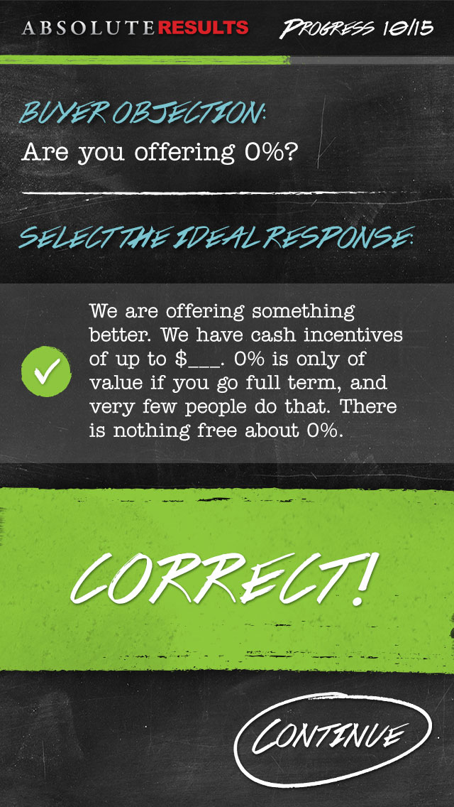 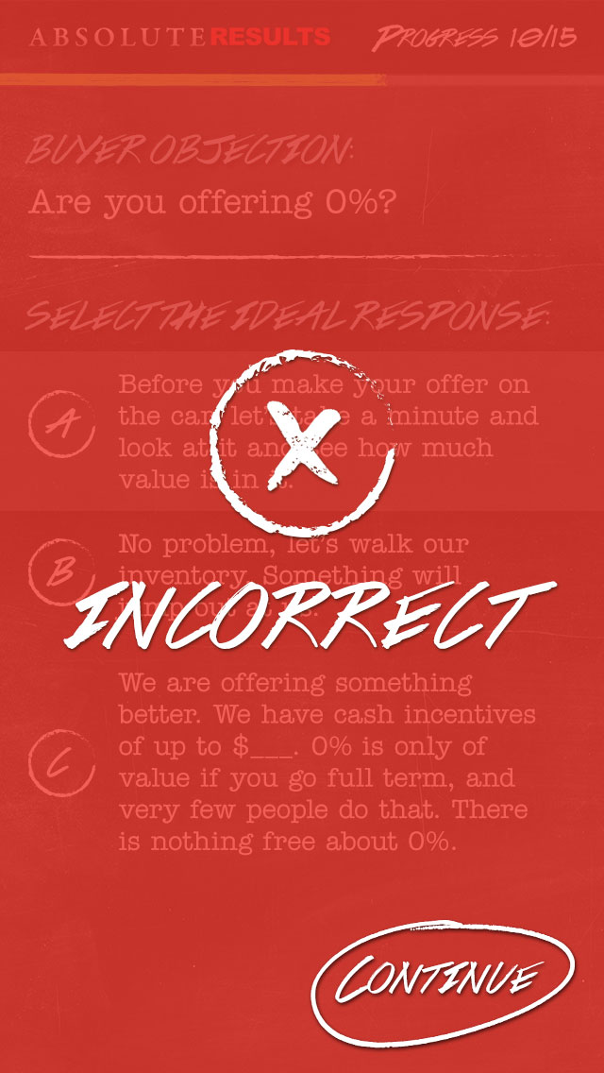

*Screen shown for a correct reponse (left), and an incorrect response (right).*

**Question Examples**

#### Standard Questions

|  |
| --- |
| *Buyer Objection:* Are you offering 0%?  *Select the ideal response:*  1. Before you make your offer on the car, let’s take a minute and look at it and see how much value is in it.  2. No problem, let’s walk our inventory. Something will jump out at us.  3. We are offering something better. We have cash incentives of up to $___. 0% is only of value if you go full term, and very few people do that. There is nothing free about 0%. |

|  |
| --- |
| *Buyer Incentive:* Avoid large repair bills!  *What is the best supporting statement?*  1. New vehicles come with 3yr/60,000KM full coverage warranties for peace of mind motoring. Full Maintenance programs are also available keeping maintenance costs fixed.  2. Due to a shortage of quality late model cars and trucks, TRADE values are higher than ever. Strong trade values allow customers to Trade sooner & preserve their vehicle EQUITY!  3. Get our Award Winning Vehicles that feature Industry leading technology, at a payment that will beat your expectations! |

#### Reverse Questions

|  |
| --- |
| *Ideal Response:* Hey it’s nice to know we are your first choice. With sales volume up, huge incentives, and low payments, let’s find you the right vehicle.  *What type of buyer objection would this response overcome?*  1. I read a critical review on this vehicle.  2. This is the first place we shopped.  3. That car is just too much money. |

|  |
| --- |
| *Supporting Statement:* Your car has never been worth more than it is TODAY. Take advantage of your EQUITY NOW– trading up TODAY will lower your cost of ownership.  *What buyer incentive does this statement support?*  1. There is a huge shortage of Pre-owned Vehicles!  2. A Variety of purchase options make it easy to buy today!  3. Get the maximum trade value for your vehicle! |

**Game Modes**

There are two different game modes to satisfy users with different levels of training intensity and to enhance engagement.

* **Quiz Mode:** Functionality described in the above section, where the user answers questions correctly to complete a session.
* **Timed Mode:** Same functionality as Quiz Mode, but the user races against a countdown timer to answer questions. They earn extra time by answering questions correctly. Goal is to answer as many questions correctly as possible before time runs out.

Progression Systems

Progression systems are used to track user activity and reward their use of the app as well as knowledge improvement of Absolute Results’ training content. The game has two progression systems: badges and levels. The user earns badges for completing certain gameplay activities. The total number of badges they’ve earned dictates their current level.

### Badges

Screen shown when the player earns  
a new badge.

The game tracks a selected number of user activities and rewards the user with special badges when they reach certain milestones or thresholds. It’s important to track activities that prove the user is spending time using the app and improving their knowledge of its content.

Examples of tracked activities include:

* Correct answers submitted
* Sessions completed
* Time spent using the app
* Login “streaks” (logging in at least once a day for X number of days)
* Average/Maximum number of sessions completed in a day

Each activity has a series of badges associated with it. The badges will be designed so that some are easy to earn, while others will take much more time and persistence.

As an example, the user could be rewarded with a badge after spending 10 minutes playing the game. This should be fairly easy for a new user to accomplish. They will be rewarded with a second badge after playing for 30 minutes, and receive a third badge at 90 minutes. The later badges require more effort to be acquired, but prove the user is using the app.

For Phase 1, up to five user activities will be tracked. Each activity will have five unique badges associated with it for a total of 25 badges. *[Final numbers are TBD.]*

### Levels

Every user begins at level 1, and advances in level by earning badges. Advancing a level is generally called “levelling up.”  New game features are unlocked once the user reaches certain levels, making it desirable to the user to play often so they have access to new content. The Phase 1 game will have a level cap, meaning that once users reach a certain level they can no longer level up. The level cap can be raised in later phases of development.

|  |  |  |  |
| --- | --- | --- | --- |
| **Level** | **Level Name** | **# of Badges Earned to Attain Level** | **Feature Unlocked** |
| 1 | 750 rpm | n/a (default level) | Quiz Mode |
| 2 | 2,000 rpm | 2 | New Objection Category |
| 3 | 3,000 rpm | 5 | Timed Mode, Reverse Question Type |
| 4 | 4,000 rpm | 10 | New Objection Category |
| 5 | 5,000 rpm | 16 | 2 New Objection Categories |
| 6 | 6,000 rpm | 25 |  |

Reward System

While earning badges and gaining levels are great ways to motivate salespeople to use the app, rewarding them with real-world prizes is a definite way to keep their attention.

When the user reaches certain levels in the game, they will receive a pre-determined reward. Rewards are not necessary for the beginning levels because users will progress through those fairly quickly. Providing rewards only at higher levels increases their impact and value to users.

Examples of possible rewards:

|  |  |
| --- | --- |
| **Level** | **Level Reward** |
| 4 | An e-book written by Absolute Results’ trainers |
| 5 | Small gift such as a pen, beer cozy or lanyard customized with Absolute Results’ logo |
| 6 | Signed copy of John Maxwell training books |

Once users have unlocked a reward, they can submit an in-app form to claim it.

**NOTE:** The rewards system does not affect the Badges and Levels systems to allow greater freedom of making adjustments, or removing the system entirely if desired. It will need to be decided whether Absolute Results or individual dealerships pay for prizes.

Retention Mechanisms

Incentives like badges are perfect for rewarding users, but we have a few extra tricks up our sleeves to keep people coming back to the training app and completing game sessions. The Phase 1 app has two key user retention mechanics:

* Unlock new game content
* Increase quiz game difficulty

### Unlock New Game Content

When the user first begins playing the game, only a subset of all available content is available to them. As discussed in the “Levels” section, the user levels up to unlock more game content.

For example, only Quiz Mode is available at Level 1, and Timed Mode is unlocked when the user reaches Level 3. Another type of unlockable content is objection categories. The user might start off only seeing quiz questions from, for example, Telephone and Closing Objection categories. Once they reach Level 2, they unlock Face to Face Objections and will see new quiz questions.

Users enjoy this type of progression because they are rewarded for progress and like to have a variety of activities to choose from.

### Increase Quiz Game Difficulty

As users increase their knowledge of the app’s content, it will become easier for them to answer quiz questions correctly. It is important to increase the difficulty of quiz questions over time to ensure users are sufficiently challenged to return to the app and continue playing (but not to the point where they fail too often and become discouraged).

Players start off by answering “Standard” type questions (for example, showing a common buyer objection and then asking players to identify the ideal response). We will increase the quiz game’s difficulty by introducing the “Reverse” questions once users have reached Level 3. Presenting the same content, but doing so in a ‘backwards’ manner, challenges the user to recall the connection between buyer objections and responses. Users will ultimately be better prepared to handle these objections on the sales floor.

Platform

Phase 1 of the Absolute Results project will be in HTML5 for mobile, putting the same app on iOS as well as Android devices for the cost of single platform development.

Releases

### Phase 1

The Phase 1 deliverable will include the features and content described above in our proposal. Additionally, we will include 2 reskins of the product with updated content and quiz questions. You will receive:

* The Absolute Results training game
* The Absolute Results employee values game
* A Chrysler-specific training game (or other manufacturer of your choice)

Please note that these reskins will not follow the schedule outlined in the development timeline below, and will be considered a separate deliverable (albeit the cost already accounted for, provided little changes graphically/functionally) to be completed at a later date.

Below is a roadmap for future phases of this game that include more features and content.

### Phase 2

* Track additional user activities, such as what categories have the best/worst user performance, or what specific Objections users
  + Note: It would be interesting to track user stats such as “number of incorrect answers submitted” or “number of cancelled sessions,” although these activities should not have badges associate with them.
* Add a new type of question: Fill in the Blank.  The user reads a buyer objection and can also see the ideal response to that objection.  However, certain key words and phrases have been removed from the response, and the user needs to fill these in using words provided in the word bank.
* New game mode: Review. Basically digital flash cards. User sees a buyer rejection or incentive, and taps the screen to reveal the correct response or supporting statement.  No quiz or timer features.
* Add more badges and levels.
* Take advantage of notifications. Research has shown that notifications increase the number of times users open and use the app.  Award-winning language-training app Duolingo sends a daily reminder from your “coach” to log in and do your daily 5 minutes of practice -- very effective!
* Run contests where all the salespeople in a store or region compete to complete the most sessions in a certain amount of time.
* Build in more incentives.  For example, if the user completes a session perfectly (doesn’t submit any incorrect answers) they receive a special badge and see a “bonus” sales tip.

### Phase 3

* Support additional types of learning content, such as:
  + Articles that summarize key takeaways of Absolute Results’ training materials.
  + Videos showing role-played sales scenarios from cards, or simply audio with photo of scenarios as a first step.
  + Digitize all training materials and handbooks and make them accessible in the app.
* Support for desktop and tablet versions of the app.
* Introduce a meta-game where users earn virtual cars and are able to “level up” these cars by adding new trim and luxury features and customize their appearance (paint job, rims, etc.).
  + This could simultaneously teach users about product lines, such as trim levels, body styles and individual options for different Chrysler models (starting with stock level for each car and progressing upward).
* Introduce a new reward incentive called tokens.  Users earn tokens for completing game activities and can redeem tokens for prizes, entries into drawings, or charity donations.

Collaboration Tools

#### Google Docs

A shared Google Docs folder contains key documents and spreadsheets including game design documents, technical design documents, balancing spreadsheets, etc… The collaborative work environment, frictionless version control, and powerful commenting system make it ideal.

#### Jira OnDemand

We use Jira for issue tracking and assigning work across the team. It also functions as a sprint planning tool for agile development.

#### Skype

Skype is a huge part of our process, giving the team simultaneous time together every day. A permanent group Skype chat is the active discussion area for work in progress. A second group Skype chat is used specifically for the daily scrum outlining what each team member plans to do every workday.

Technology

#### Engine

We use HTML5 for mobile as it allows the flexibility to develop once for multiple mobile platforms.

#### GitHub

GitHub is our code repository.

#### Jenkins

Jenkins is the tool we use for continuous integration.

#### Testing Devices

The team can test on iPad, iPhone, and Android devices.

Organization

**Absolute**

**Results**

**Producer/ Designer**

Art

Engineering

Quality Assurance

Development Process

* Our team runs on an agile model with weekly sprints with planning occurring on Fridays for the following week.
* We have a daily SCRUM on Skype to keep the entire team informed and accountable to each other.
* On Fridays we have a Google hangout and test the latest build as a team, discussing issues and ideas for improvement.

Development Phases & Initial Timeline

Due to significant delays around the November and December holidays, the sooner the project is underway the more likely we are to see the product launched on time. We highly recommend beginning the design and programming work before October.

#### HTML5 for Mobile Development (8 weeks)

A limited functionality prototype will be quickly created to address initial “look and feel”.

Full production of features along with art and audio integration will continue for another 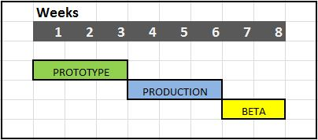month. Final QA testing will occur during a Beta period.

Milestones

**Milestones**

* Prototype – A prototype will be delivered after three weeks to allow better assessment of art and design.
* Beta – The Phase 1 features will be in production until Beta, at which point the majority of QA testing will occur and remaining bugs will be triaged.
* Delivery – Delivery will occur at the end of Beta with the product ready for an initial launch on iOS and Android.

To ensure timely delivery, the AC+A Project Manager must sign off on feature requests that occur once the project is underway. Noteworthy changes may require readjustment of deliverable dates or cost.

AC+A is…

#### Adrian Crook

*Managing Director, AC+A*

Adrian has designed and managed products for over three dozen clients. Working with top-tier companies such as Zynga and Electronic Arts, Adrian has been a key contributor on hit titles such as FrontierVille for which he designed two of the five top-grossing features.

### Design

#### Jordan Blackman

Jordan has extensive design experience at industry-leading companies such as Ubisoft and Zynga. In addition to his earlier work on franchises such as Ubisoft’s CSI, Jordan was lead designer on Facebook favorites CastleVille and Frontierville.

#### Wes Leviton

Wes has held designer and producer positions at well-known companies such as Gameloft, Glu Mobile, and Zynga, where he took part in the design of Zynga Bingo. As product manager at Red Robot Labs he contributed to Life Is Crime and Life Is Magic.

#### Gwendolyn Mullinix

Gwendolyn has worked on numerous educational video games for government agencies such as IARPA and TATRC, as well as leading healthcare brands including Duke University School of Medicine and Kaiser Permanente.

### Engineering

#### Karl Schmidt

Karl’s programming background includes projects on mobile platforms, PC, Xbox360, and PS3. While an engineer at Relic Entertainment he contributed to notable titles such as Company of Heroes, Dawn of War 2, and Space Marine.

#### Aaron Dale

Aaron has extensive experience with iOS, Android, Linux, and web games. His programming work can be found in titles such as PlayRank, Samantha Plum, and Animal Academy.

### Art

#### Seann Einerssen

Seann is an accomplished motion graphics animator & web designer. Over the past 10 years he has created award winning media campaigns and branding for numerous clients.

#### Lasko Konopa

Lasko has been an art director at top-tier companies such as PopCap Games and Stormfront Studios. His work can be seen in well-known titles such as Mahjong Escape, Mystery Solitaire, and HoverBee Studios’ Undiscovered World games.

### Audio

#### Jeff Tangsoc

Studio Manager of Power Up Audio, Jeff has worked on over 200 games. His contributions can be heard on titles such as Cityville, Peggle, and award-winning League of Legends.

### Quality Assurance

#### Cristopher Descoeurs

Cristopher’s background includes specialist and lead testing positions at industry-leading companies such as Electronic Arts and Ubisoft. He’s worked on such highly acclaimed titles as Assassin’s Creed Black Flag and Watch Dogs.

### Project Management

#### Keith Fuller, CSM PMP

Founder and principal consultant at Fuller Game Production, Keith is a certified scrum master and project management professional. He has worked with teams of up to 200 as leadership consultant, project manager, and process improvement specialist.